Application Opened
Main content

Features
To ensure a successful learning experience, this book includes the following pedagogical features:
- Learning Objectives. Every chapter opens with a list of learning objectives that sets the stage for you to absorb the lessons of the text.
- Comprehensive Step-by-Step Troubleshooting Guidance. Troubleshooting guidelines are included in almost every chapter. In addition, Chapter 4 gives insights into general approaches to troubleshooting that help apply the specifics detailed in each chapter for different hardware and software problems. Chapters 8, 14, and 15 also focus on troubleshooting networks, applications, and Windows.
- Step-by-Step Procedures. The book is chock-full of step-by-step procedures covering subjects from hardware and operating system installations and maintenance to troubleshooting the boot process or a failed network connection and optimizing system performance.
- Visual Learning. Numerous visually detailed photographs, three-dimensional art, and screenshots support the text, displaying hardware and software features exactly as you will see them in your work.
- CompTIA A+ Table of Contents. This table of contents gives the chapter and section that provides the primary content for each certification objective on the A+ exams. This is a valuable tool for quick reference.
- Applying Concepts. These sections offer real-life, practical applications for the material being discussed. Whether outlining a task, developing a scenario, or providing pointers, the Applying Concepts sections give you a chance to apply what you’ve learned to a typical computer or network problem, so you can understand how you will use the material in your professional life.
  - 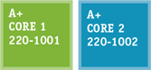A+ Icons. All of the content that relates to CompTIA’s A+ Core 1 and A+ Core 2 Certification exams is highlighted with an A+ icon. The icon notes the exam name and the objective number. This unique feature highlights the relevant content at a glance, so that you can pay extra attention to the material.
  - Notes. Note icons highlight additional helpful information related to the subject being discussed.
  - A+ Exam Tip Boxes. These boxes highlight additional insights and tips to remember if you are planning to take the CompTIA A+ exams.
  - Caution Icons. These icons highlight critical safety information. Follow these instructions carefully to protect the computer and its data and to ensure your own safety.
  - OS Differences. These boxes point you to the differences among Windows 10, Windows 8, and Windows 7.
- End-of-Chapter Material. Each chapter closes with the following features, which reinforce the material covered in the chapter and provide real-world, hands-on testing:
  - Chapter Summary: This bulleted list of concise statements summarizes all major points of the chapter.
  - Key Terms: The content of each chapter is further reinforced by an end-of-chapter key term list. The definitions of all terms are included with this text in a full-length glossary.
  - Thinking Critically Questions: You can test your understanding of each chapter with a comprehensive set of “Thinking Critically” questions to help you synthesize and apply what you’ve learned in scenarios that test your skills at the same depth as the A+ exams.
  - Hands-On Projects: These sections give you practice using the skills you have just studied so that you can learn by doing and know you have mastered a skill.
  - Real Problems, Real Solutions: Each comprehensive problem allows you to find out if you can apply what you’ve learned in the chapter to a real-life situation.
- Student Companion Site. Additional content included on the companion website includes Electricity and Multimeters, and FAT Details. Other helpful online references include Frequently Asked Questions, Sample Reports, a Computer Inventory and Maintenance form, and Troubleshooting Flowcharts.

What’s New in the Tenth Edition
Here’s a summary of what’s new in the Tenth Edition:
- Content maps to all of CompTIA’s A+ Core 1 and Core 2 exams.
- There is now more focus on A+, with non-A+ content moved online to the companion website or eliminated.
- The chapters focus on Windows 10 with some content about Windows 8/7.
- New content is added (all new content was also new to the A+ Core 1 and Core 2 exams).
  - Windows 10 is added. Operating systems covered now include Windows 10, Windows 8, and Windows 7. New content on Linux, macOS, and mobile operating systems (Android, iOS, Windows Phone, and Chrome OS) is added.
  - New content on Active Directory Domain Services is covered in Chapter 16.
  - New content on understanding and writing scripts is covered in Chapter 18.
  - Enhanced content on supporting mobile devices (including the Android OS, iOS, Windows Phone, and Chrome OS) is covered in Chapter 9.
  - New content on virtualization and cloud computing is covered in Chapter 10.
  - Hands-On Projects in several chapters use virtual machines so that you get plenty of practice using this essential cloud technology.
  - New content on change management, network topology diagrams, regulatory and compliance policies, acceptable use policies, inventory management, and regulated data is covered in Chapter 17.
  - New content on VLANs and managed switches is covered in Chapter 8.
  - The Internet of Things (IoT) and how to set up a smart home are covered in Chapter 9.
  - Content on supporting and troubleshooting laptops is integrated throughout the text.

Features of the New Edition
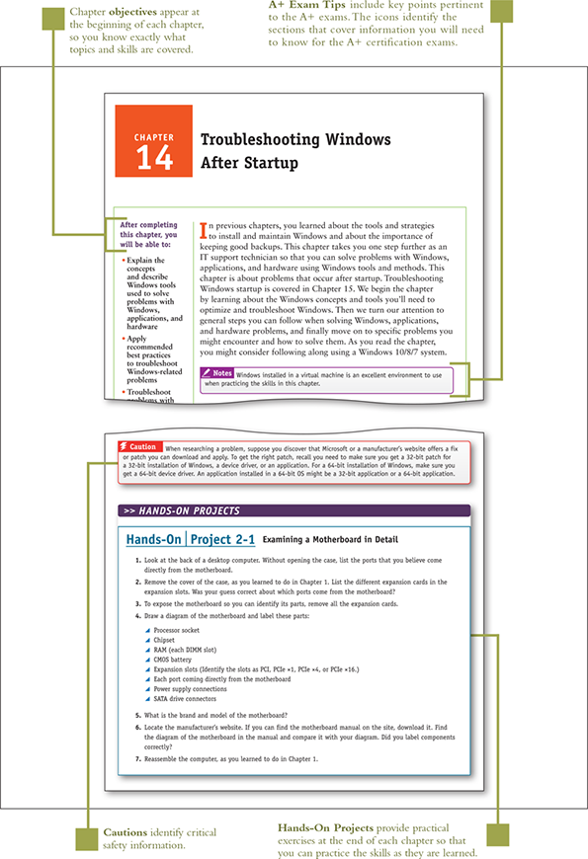
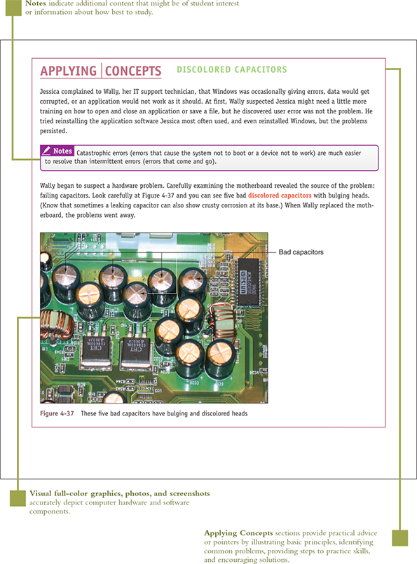
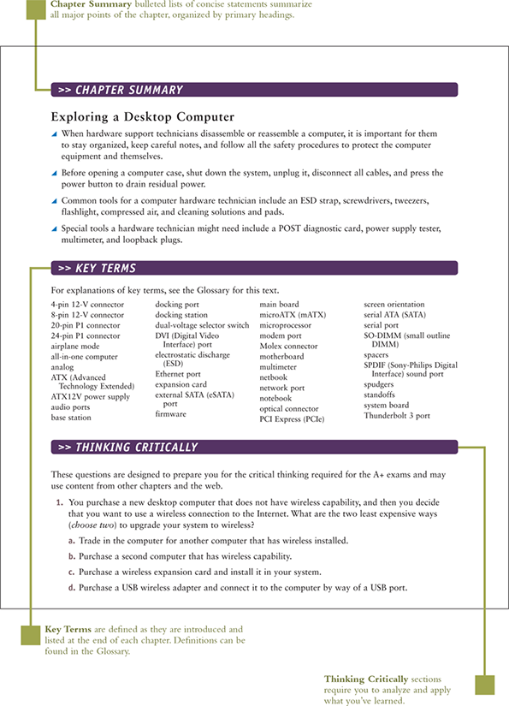
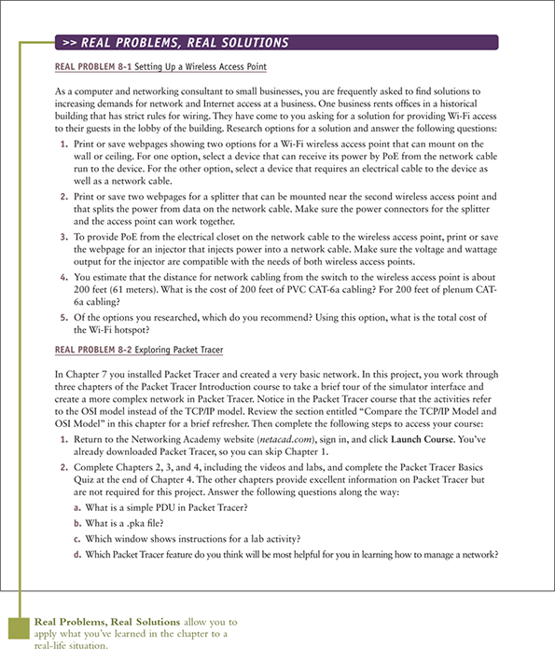

What’s New with CompTIA® A+ Certification
The CompTIA A+ certification includes two exams, and you must pass both to become CompTIA A+ certified. The two exams are Core 1 (220-1001) and Core 2 (220-1002).
Here is a breakdown of the domain content covered on the two A+ exams.
CompTIA A+ 220-1001 Exam
Domain | Percentage of Examination
1.0 Mobile Devices | 14%
2.0 Networking | 20%
3.0 Hardware | 27%
4.0 Virtualization and Cloud Computing | 12%
5.0 Hardware and Network Troubleshooting | 27%
Total | 100%
CompTIA A+ 220-1002 Exam
Domain | Percentage of Examination
1.0 Operating Systems | 27%
2.0 Security | 24%
3.0 Software Troubleshooting | 26%
4.0 Operational Procedures | 23%
Total | 100%
Go to pg.
help

